Taj Brands

Therapeutic Index

Each film coated tablet contains:
Composition:
Mifepristone.....................................................................200 mg
Excipients........ .......................................................................q.s.
Indications:
Mifebort is indicated for the medical termination of intrauterine pregnancy through 49 days pregnancy. For purposes of this treatment, pregnancy is dated from the first day of the last menstrual period in a presumed 28 day cycle with ovulation occurring at mid-cycle. Any intrauterine device [IUD] should be removed before treatment with Mifebort begins. Patients taking Mifebort must take 400 mg of Misobort two days after taking mifepristone unless a complete abortion has already been confirmed before that time (see Dosage And Administration). Pregnancy termination by surgery is recommended in cases when Mifebort and Misobort fail to cause termination of intrauterine pregnancy.
Description:
Mifepristone blocks the hormone progesterone needed to maintain the pregnancy. Because this hormone is blocked, the uterine lining begins to shed, the cervix begins to soften and bleeding may occur. With the later addition of the second medication, misoprostol, the uterus contracts and the pregnancy is usually expelled within 6 to 8 hours.
Because the woman decides when to take the second medication within the time frame of 24 to 72 hours after the first medication, she has some control over when she experiences the miscarriage and its side effects. Some women choose the Abortion Pill because of the privacy it offers. Some women feel empowered by taking an active role in the process.
Mifepristone effect on reproductive system
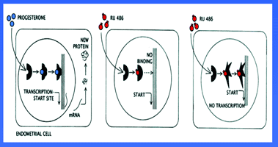

Side Effects
Most of the side effects when using this early abortion option are caused by the second medication, misoprostol. Side-effects may include heavy bleeding, headache, nausea, vomiting, diarrhea, and heavy cramping.
Dosage :
Treatment with Mifebort and Misobort for the termination of pregnancy requires three office visits by the patient. Mifebort may be administered only in a clinic, medical office, or hospital, by or under the supervision of a gynecologist, able to assess the gestational age of an embryo and to diagnose ectopic pregnancies. Gynecologist must also be able to provide surgical intervention in cases of incomplete abortion or severe bleeding, if necessary. Mifebort. Unless abortion has occurred and has been confirmed by clinical examination or ultrasonographic scan, the patient takes two 200 mg tablets (400 mg) of Misobort orally.
Presentations : 1 tablet
MRP Retailer Stockiest
330.00 264.00 237.60

